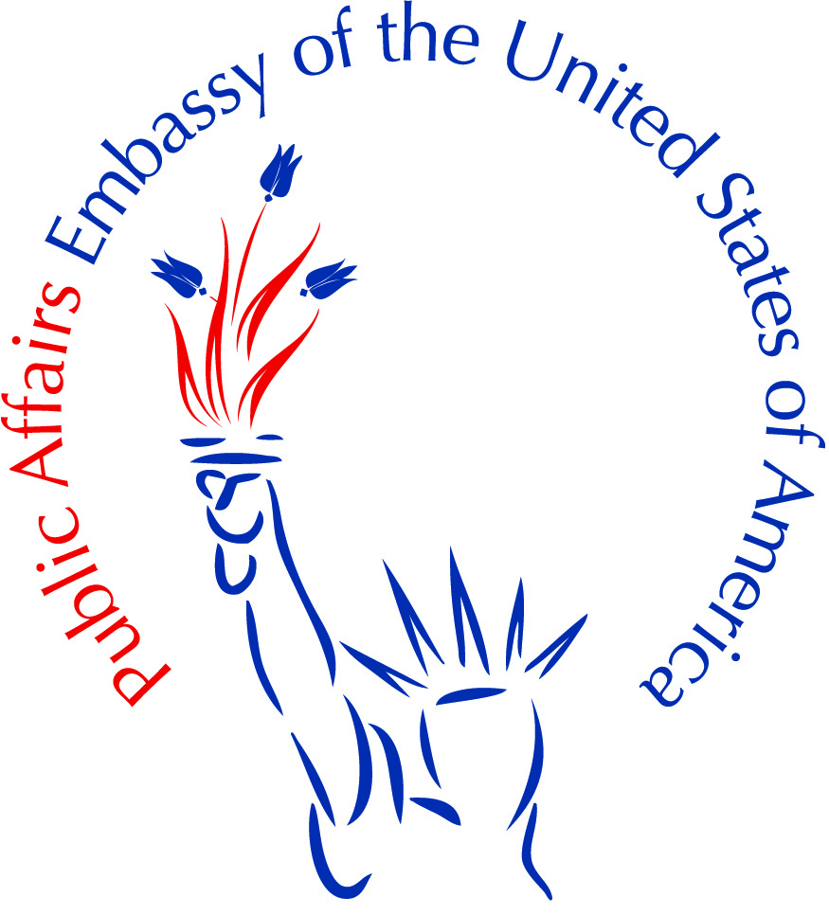
SUMMER 2015 STUDY OF THE U.S. INSTITUTES FOR SCHOLARS
ABOUT THE PROGRAM
Study of the U.S. Institutes for Scholars will take place at various colleges, universities, and institutions throughout the United States over the course of six weeks beginning in or after June 2015. Each Institute includes a four week academic residency component and up to two weeks of an integrated study tour. Posts and prospective applicants are encouraged to visit our website page to obtain general information about the Institutes. The website address is: http://exchanges.state.gov/susi.
TARGET AUDIENCE
Candidates should be mid-career, typically between the ages of 30-50, highly-motivated, experienced scholars and professionals generally from institutions of higher education or research focused organizations (not-for-profits, think tanks, etc.) with excellent English skills. While the educational level of participants will likely vary, most should have graduate degrees and have substantial knowledge of the thematic area of the Institute or a related field. While we prefer candidates who have not studied or lived in the United States before, they also have be Turkish nationals.

INSTITUTE THEMES:
• The Institute on Contemporary American Literature will provide a multinational group of up to 18 foreign university faculty and scholars with a deeper understanding of U.S. society and culture, past and present, through an examination of contemporary American (U.S.) literature. Its purpose is twofold: to explore contemporary American writers and writing in a variety of genres; and to suggest how the themes explored in those works reflect larger currents within contemporary U.S. society and culture. The program will explore the diversity of the American literary landscape, examining how major contemporary writers, schools, and movements reflect the traditions of the U.S. literary canon. At the same time, the program will expose participants to writers who represent a departure from that tradition, and who are establishing new directions for American literature. Pending ECA grant approval, the Institute will be hosted by the University of Louisville located in Louisville, Kentucky.
• The Institute on Journalism and Media will provide a multinational group of 18 journalism instructors and other related specialists with a deeper understanding of the roles that journalism and the media play in U.S. society. The Institute will examine the rights and responsibilities of the media in a democratic society, including editorial independence, journalistic ethics, legal constraints, international journalism, and media business models. The Institute will cover strategies for teaching students of journalism the basics of the tradecraft: researching, reporting, writing, and editing. The program will also highlight technology's impact on journalism, such as the influence of the internet, the globalization of the news media, the growth of satellite television and radio networks, and other changes in media that are transforming the profession. Pending ECA grant approval, the Institute will be hosted by Ohio University.

• The Institute on Religious Pluralism in the United States will provide a multinational group of up to 18 foreign university faculty and practitioners with a deeper understanding of U.S. society and culture, past and present, through an examination of religious pluralism in the United States and its intersection with American democracy. Employing a multi- disciplinary approach and drawing on fields such as history, political science, sociology, anthropology, law, and others, the program will explore both the historical and contemporary relationship between church and state in the United States. Participants will examine the following aspects of religious pluralism in the United States: the ways in which religious thought and practice have influenced, and been influenced by, the development of American-style democracy; the intersections of religion and politics in the United States in such areas as elections, public policy, and foreign policy; and the sociology and demography of religion in the United States today, including a survey of the diversity of contemporary religious beliefs and its impact on American politics and society. Pending ECA grant approval, the Institute will be hosted by the University of California, Santa Barbara.
• The Institute on U.S. Culture and Society will provide a multinational group of 18 experienced and highly-motivated foreign university faculty and other specialists with a deeper understanding of U.S. society, culture, values, and institutions. The Institute will examine the ethnic, racial, social, economic, political, and religious contexts in which various cultures have manifested themselves in U.S. society while focusing on the ways in which these cultures have influenced social movements and American identity throughout U.S. history. The program will draw from a diverse disciplinary base, and will itself provide a model of how a foreign university might approach the study of U.S. culture and society. Pending ECA grant approval, the Institute will be hosted by New York University.
• The Institute on U.S. Foreign Policy will provide a multinational group of 18 experienced foreign university faculty and practitioners with a deeper understanding of how contemporary U.S. foreign policy is formulated and implemented. The Institute will include a historical review of significant events, individuals, and philosophies that have shaped U.S. foreign policy. The Institute will explain the role of key players in U.S. foreign policy including the executive and legislative branches of government, the media, the U.S. public, think-tanks, non-governmental organizations, and multilateral institutions. Pending ECA grant approval, the Institute will be hosted by Bard College in New York.
• The Institute on U.S. Political Thought will provide a multinational group of 18 experienced foreign university faculty and practitioners with a deeper understanding of major currents in U.S. political thought from the colonial period to the present. Drawing upon the American Political Development approach, the Institute will provide a full and diverse understanding of U.S. political thought its connection to U.S. politics and institutions by linking contemporary issues with historical debates. The Institute will explore particular themes including self-rule and limited government, liberty and freedom, individualism and identity, equality and inequality, and the American dream. The Institute concludes with an integrated two-week study tour to Boston, New York City, Gettysburg, Harrisburg, Charlottesville, and Washington, D.C. Pending ECA grant approval, the Institute will be hosted by the University of Massachusetts Donahue Institute located in Amherst, MA.
APPLICATION PROCESS:
All communications and questions regarding the Institutes should be addressed to Deniz A. Gursan at the US Mission in Ankara at americanembassyankara@gmail.com

Please identify a candidate for the each institute and send it to americanembassyankara@gmail.com with Subject line SUSI2015 by December 26, 2014, with a resume which should include mobile number, and an email address and a motivation letter on why the scholar is applying for the program.

